UAV Intermediate Flight Skill 1
- Slalom/ figure eight course -
Objective: To teach the student practical flight skills when operating in or near tight areas
Discussion topics:
- Setup of launch/landing area
- Set up 4 swimming noodles in a line 10 feet apart
- Capabilities and limitations of UAV obstacle avoidance systems
- Use of orientation and anti-collision strobe lights
- Emergency procedures for lost signal
- Visual camera low light performance
- Equipment and accessories specific to night operations
- Communications with visual observers
- Use of FPV view for approaching and flying around the course
___________________________________________________________________
Pilot exercises:
- Setup launch/landing area
- Setup of UAV orientation and anti-collision strobe lights
- Takeoff and function check
- Flight by visual line-of-sight
- Flight by FPV
- Communicate and coordinate with visual observer
- Perform an approach and landing
__________________________________________________________________________________________
Common mistakes:
- Not accounting for night vision adaptation
- Improper setup of UAV orientation and anti-collision lighting
- Unable to determine orientation, proximity and control at distance
- Unable to utilize FPV and telemetry to locate poles and fly around course
- Failure to maintain situational awareness of aircraft and hazards
- Failure to communication and coordinate with visual observer
- Failure to understand visual camera limitations
___________________________________________________________________Completion standards:
- Pilot performs a site survey and identifies hazards
- Pilot correctly installs orientation and anti-collision strobe lights
- Pilot accounts for visual camera limitations
- Pilot maintains control of aircraft during flight and maintains orientation based on VLOS and FPV
- Pilot communicates and coordinates with the visual observer
- Pilot will demonstrate the ability to fly around pylons and avoid colliding with the pylons
- Pilot is able to approach the launch/landing area and prepare for landing
- Pilot performs a safe landing by FPV

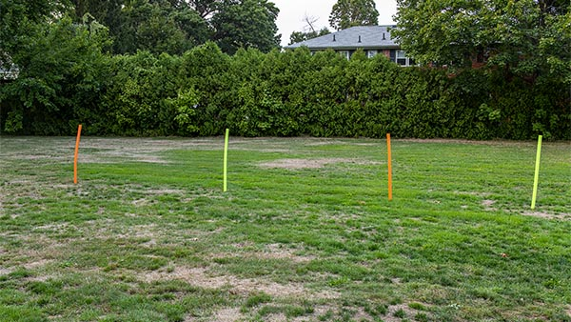

Basic set up

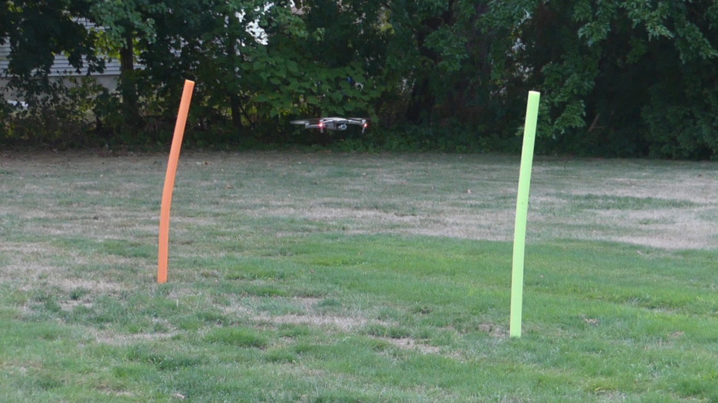

Flying the drone in a figure 8 pattern in and out of the noodles

