UAV Basic Flight Skills 6a and 6b
- Box/square pattern with nose of sUAV pointing away from pilot and towards -
Objective: To teach the student basic l flight skills when operating any team sUAV
Discussion topics:
- Capabilities and limitations of the joysticks
- Setup of launch/landing area
- Capabilities and limitations of UAV obstacle avoidance systems
- Knowledge of orientation of UAV
- Communications with visual observers
- Use of FPV view for approach and landing
___________________________________________________________________
Student exercises:
- Setup launch/landing area
- Set up 4 parking cones in a square 25 (twenty five) feet apart
- Setup of UAV orientation (always facing away from the pilot)
- Takeoff, function check and bring UAV up to 6 feet AGL
- Flight by visual line-of-sight keeping the UAV pointing away from the pilot
- Navigate clock wise around the cones in a box pattern for four sides or one orbit
- Communicate and coordinate with visual observer
- Land the UAV on its landing pad facing away from the pilot
__________________________________________________________________________________________
Common mistakes:
- Improper setup of UAV orientation and anti-collision lighting
- Unable to determine orientation and control at distance
- Unable to utilize FPV and telemetry to locate launch/landing area
- Failure to maintain situational awareness of aircraft and hazards
- Failure to communication and coordinate with visual observer
- Failure to understand visual camera limitations
- Failure to land the UAV in any orientation other than pointing directly away from the pilot
___________________________________________________________________Completion standards:
- Student launches drone to 6 feet AGL
- Student performs a clock wise orbit (see attached drawing #1) with UAV orientated away from the pilot at all times
- Student performs a clock wise orbit (see attached drawing #2) with UAV oriented towards the pilot at all times
- Student understands the use of the both sticks to control the flight
- Student maintains control of aircraft during flight and maintains orientation based on VLOS and FPV
- Student communicates and coordinates with the visual observer
- Student is able to approach the launch/landing area and prepare for landing with proper orientation

Drawing #1
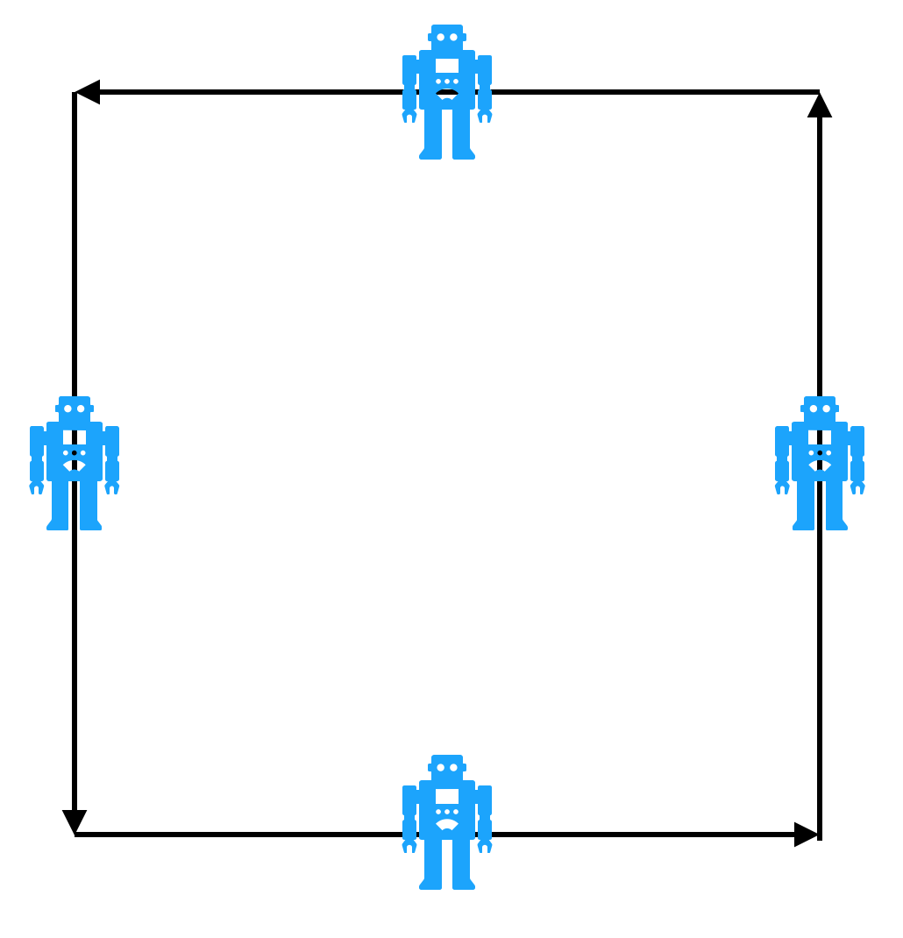

X
Pilot stands here

Drawing #2

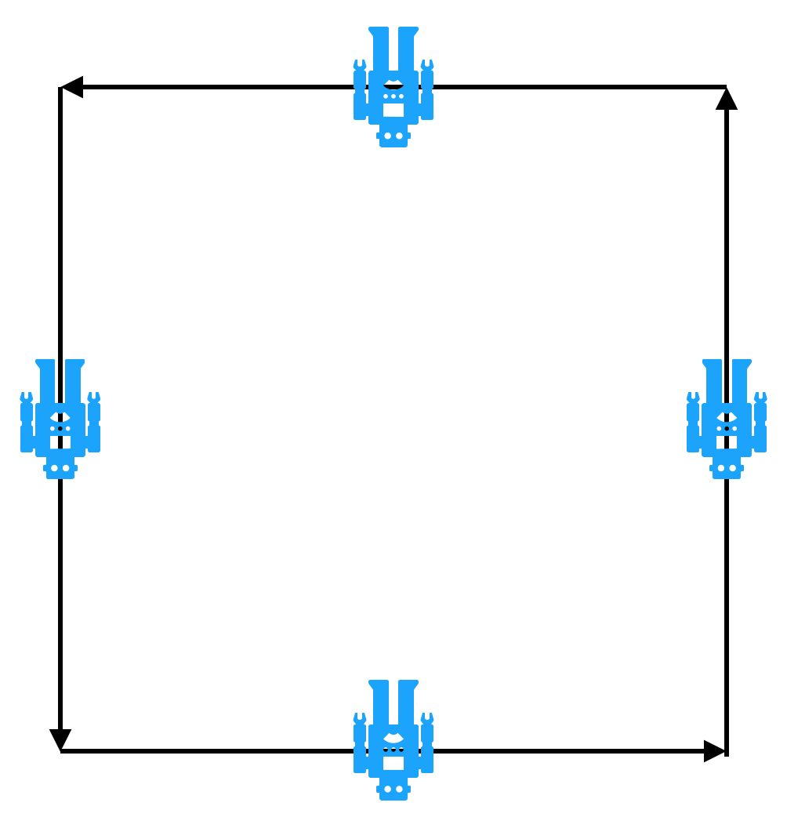
X
Pilot stands here

